**Python and Deep Learning**

**CSEE5590/490 APS**

**Lab Assignment -1**

**Submitted by:**

**K.N.V.Saiindra Kumar**

**T.V.S.Sai Ram**

1. **Introduction**

Searching in a string and finding the non-repeated characters in that string

Programming a code to remove everything in file1 which is inside in file2

Reading the lists and finding the asymmetric differences between them

Management Systems

Download and the parsing the webpage and storing the webpage in the table

1. **Objectives**
   1. We tend to apply dictionaries, arrays, iterations in strings to find the non-repeated character in the string.
   2. We checked how to use split function and reading and looping to remove the content in file 1 which is inside file2.
   3. Applied asymmetric difference between two sets to get the new list of students in one class
   4. Used concepts of functions and constructors to create hospital database management system.
2. **Approaches**

We used class, constructor, inheritance, multiple inheritance and object-oriented concepts in order to implement the hospital management systems and using beautifulsoup library we downloaded and parsed the web page and stored in the table.

1. **Workflow**

**Question 1**

We created the character array to store the character string from the input we gave in and it parses one letter by letter and stores it finally in the count variable and we displayed the string[index] and we displayed the non-repeated character.

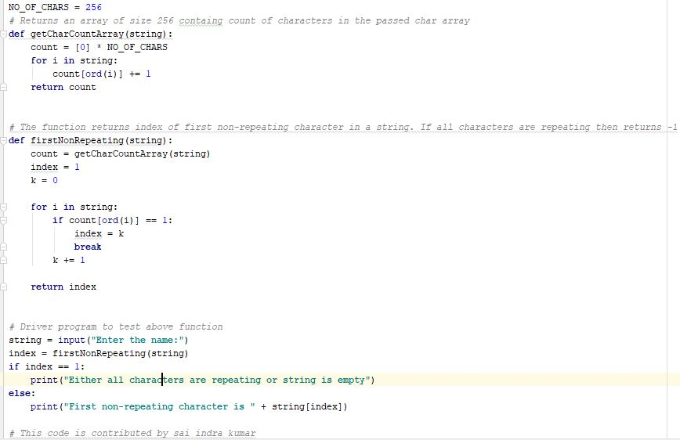

**OUTPUT**

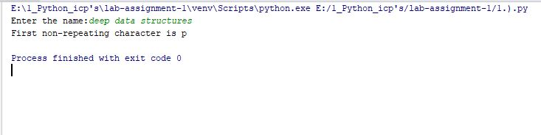

**Question 2**

We took the two files and and read those files in to the new variable file1 and file2 and we split them and convert into the lower case and open it through write access and using looping constructs we check the files and whether they are present in one another and remove one from another.

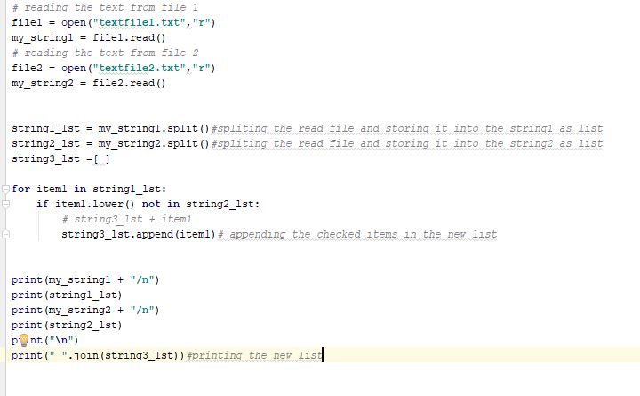

**OUTPUT**

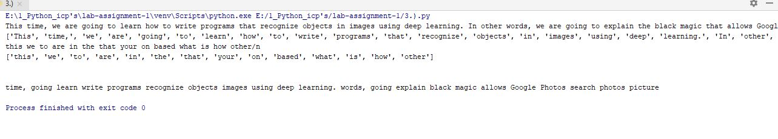

**QUESTION 3**

In this program we considered two lists who are attending the python class and web class and using the asymmetric difference we can separate the list and print the list.

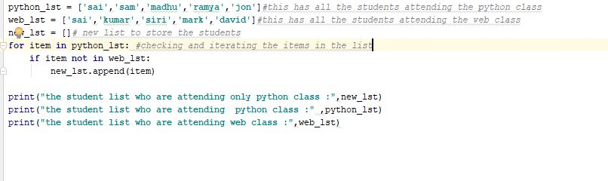

**OUTPUT**

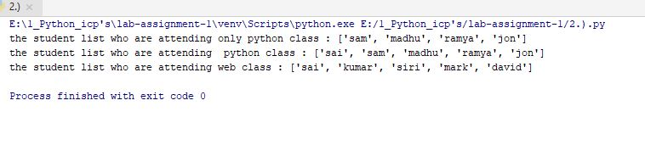

**QUESTION 4**

In this question we created Hospital class, doctor class, patient class and clerk class, book class, using the inheritance and multiple inheritance concepts we mapped the parameters and finally we defined the list and append the objects by creating instances of all the classes.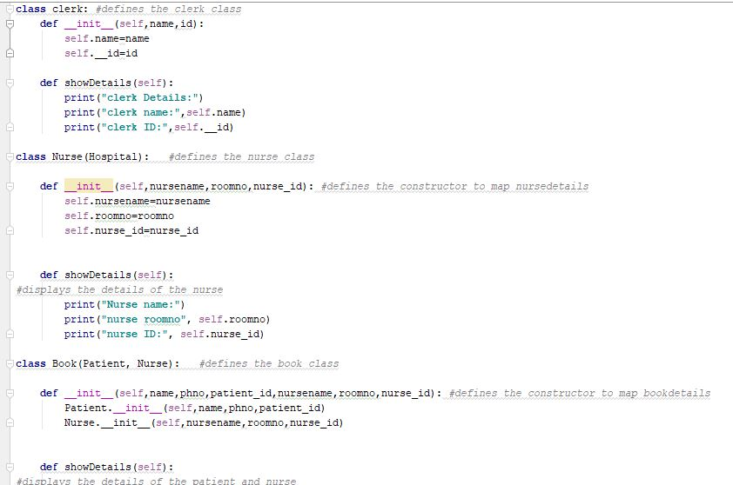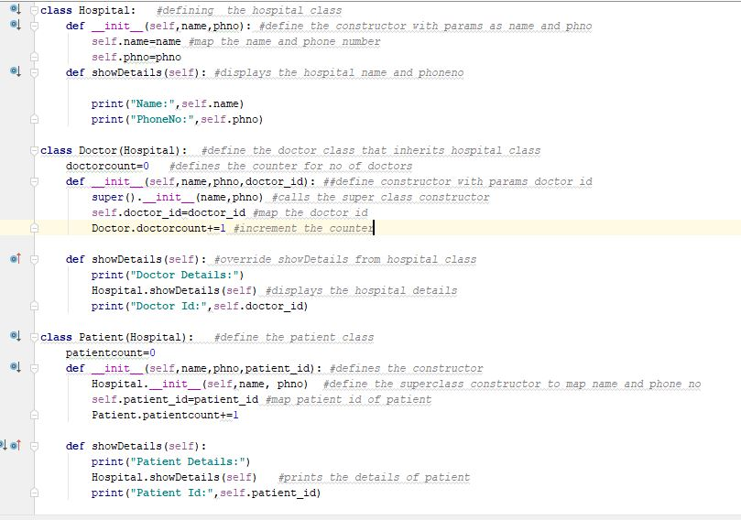

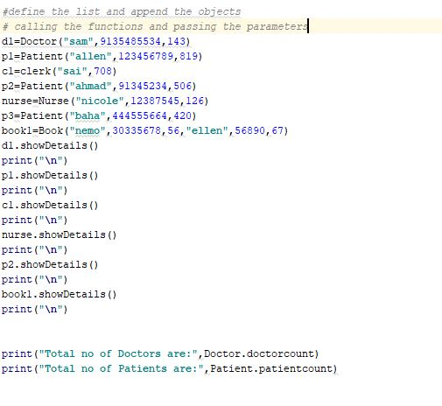

**OUTPUT**

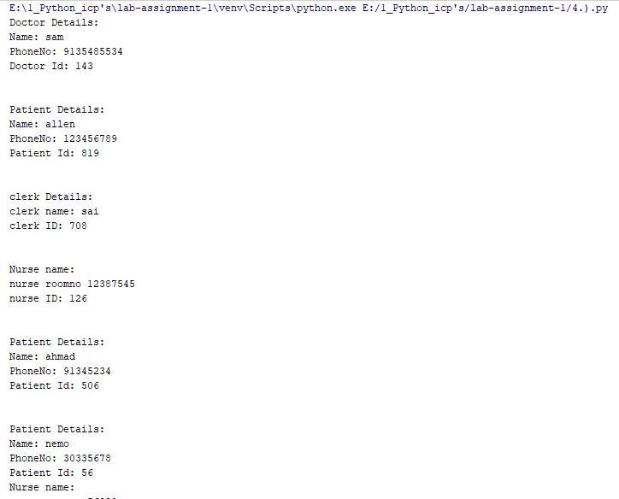

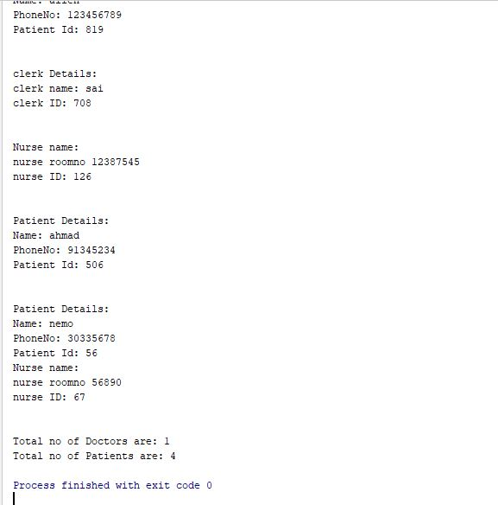

**QUESTION 5**

In this question we imported the url using request library and assign a link to the variable and open the link and using the parser we parsed the page in the wiki page and stored in the table by looping all the elements in the tr and td tags.

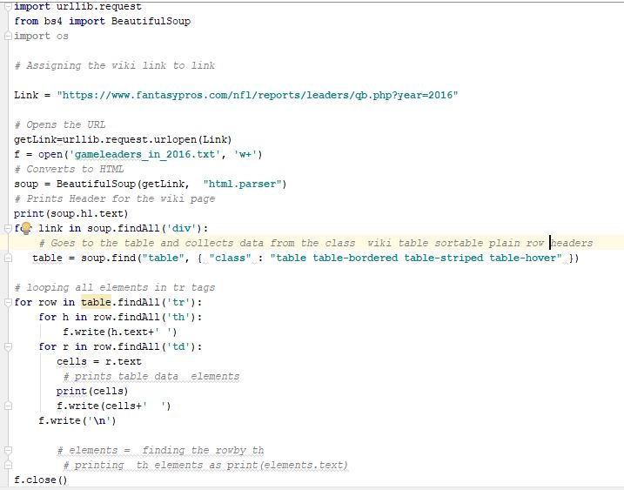

**OUTPUT**

